**Project Design Phase-II**

**Data Flow Diagram &User Stories**

|  |  |
| --- | --- |
| Date | 19 October 2022 |
| Team ID | PNT2022TMID37704 |
| Project Name | Inventory Management System for Retail Store |
| Maximum Marks | 4 Marks |

**Data Flow Diagrams:**

A Data Flow Diagram (DFD) is a traditional visual representation of the information flows within a

system. A neat and clear DFD can depict the right amount of the system requirement graphically. It shows how data enters and leaves the system, what changes the information, and where data is stored.

**Example:**

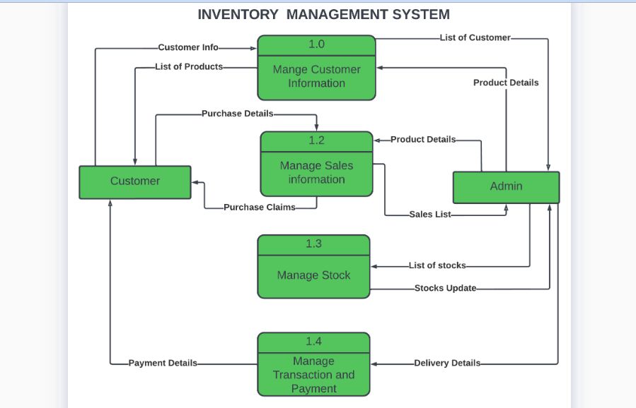

**User Stories**

List of all the user stories for the product :

|  |  |  |  |  |  |  |
| --- | --- | --- | --- | --- | --- | --- |
| **User Type** | **Functional**  **Requirement ­(Epic)** | **User Story**  **Number** | **User Story / Task** | **Acceptance criteria** | **Priority** | **Release** |
| Customer  (Mobile user) | Registration | USN-1 | As a user, I can register for the application by entering my email, password, and confirming my password. | I can access my account / dashboard | High | Sprint-1 |
| USN-2 | As a user, I will receive confirmation email once I have registered for the application | I can receive confirmation email & click confirm | High | Sprint-1 |
| USN-3 | As a user, I can register for the application through Gmail | I can register & application  Through Gmail | Medium | Sprint-1 |
| Login | USN-4 | As a user, I can log into the application by entering email & password | I can access my account | High | Sprint-1 |
| Dashboard | USN-5 | As a user,I can track data of sales of products and inventory levels | I can track data of sales and products and inventory levels. | High | Sprint-1 |
| Customer (Web  user) | Registration | USN-6 | As a user,I can register for the application by entering my email, password, and confirming my password | I can access my account/Dashboard | High | Sprint-1 |
| USN-7 | As a user, I will receive confirmation email once I have registered for the application | I can receive confirmation email & click confirm | High | Sprint-1 |
| USN-8 | As a user ,I can register for application through Gmail | I can upload my Profile photo/Name in my account | Medium | Sprint-1 |
| Customer Care Executive | Customer Support | USN-9 | As a user,I can support for customers to handle queries and complaints from their problems | I can support for customers to clear | High | Sprint-1 |

|  |  |  |  |  |  |  |
| --- | --- | --- | --- | --- | --- | --- |
| **User Type** | **Functional**  **Requirement (Epic)** | **User Story**  **Number** | **User Story / Task** | **Acceptance criteria** | **Priority** | **Release** |
| Administrator | Manage the Stocks | USN-10 | As a administrator, I manage the stocks by adding, shipping and stores the stocks in the storage units | I manage the stocks by adding, shipping and storing the stock in the storage units. | High | Sprint -1 |
|  | Responsibility | USN-11 | As a administrator, I can control all the users by performing basic CRUD operations. | I Can control all the users by performing basic CRUD operations. | High | Sprint -1 |
|  | Access the database | USN-12 | As a system administrator, I can control and access the database | I can control and access the database | High | Sprint -1 |